**Experiment:** 8051 Assignment for LED on/off hardware test.

**Objective:** Blink a LED using 8051 Microcontroller.

**Hardware Component:**

* 8051 (STC89C52RC) Microcontroller kit.
* USBASP USBISP AVR Programmer
* 1x While LED.
* 1x 100 Ohm Resistor.
* Jumper Wires.

**Software Component (Proteus):**

* 80C51 Microprocessor
* 1x Crystal
* 2x 33P Ceramic Capacitor
* 1x 300 ohm Resistor
* 1x White LED.

**Software Used:**

* KEIL MDK V6 Community Edition
* STC ISP V6.90
* Proteus V8.13

**Procedure:**

* Write the Micro C programming code for blink the led.
* Design the circuit into proteus.
* Implement the hardware circuit.
* Generate a Hex file using KEIL software.
* Load the Hex file into 80C51 on Proteus
* Load the Hex file into STC89C52RC using STC ISP software.

**Circuit Diagram:**

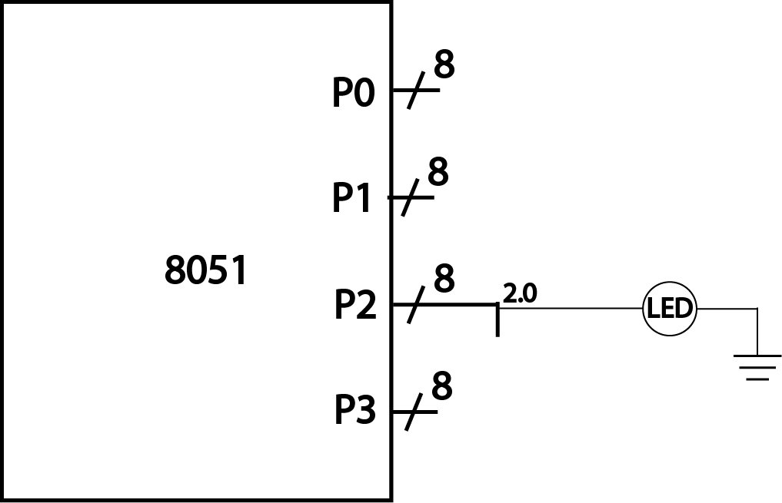

**Code:**

|  |
| --- |
| **/*** Led_blink.c ***/**  **#include<reg51.h>**  **sbit led = P2^0;**  **void Delay(void);**  **void main()**  **{**  **led = 0;**  **while(1)**  **{**  **led = 1;**  **Delay();**  **led = 0;**  **Delay();**  **}**  **}**  **void Delay(void)**  **{**  **int j;**  **int i;**  **for(i = 0; i<10; i++)**  **{**  **for(j = 0; j< 10000; j++)**  **{**  **}**  **}**  **}** |

**Proteus Circuit Screenshots:**

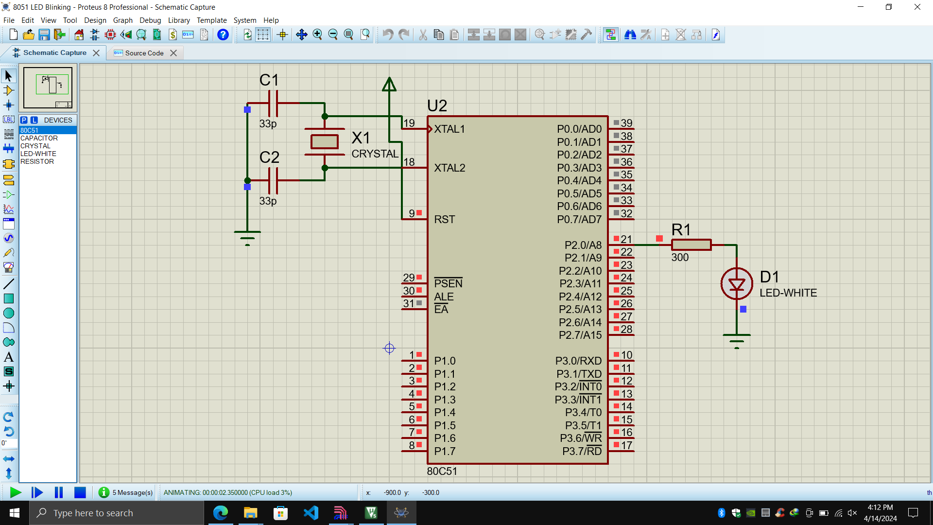

**Hardware Circuit Image:**

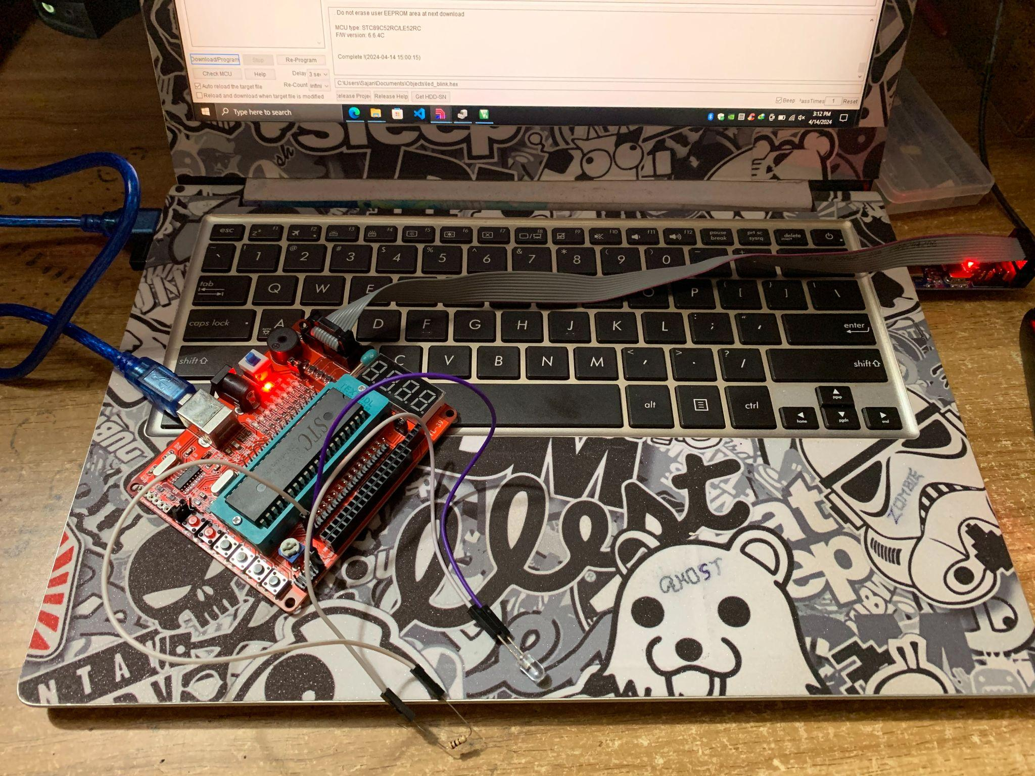

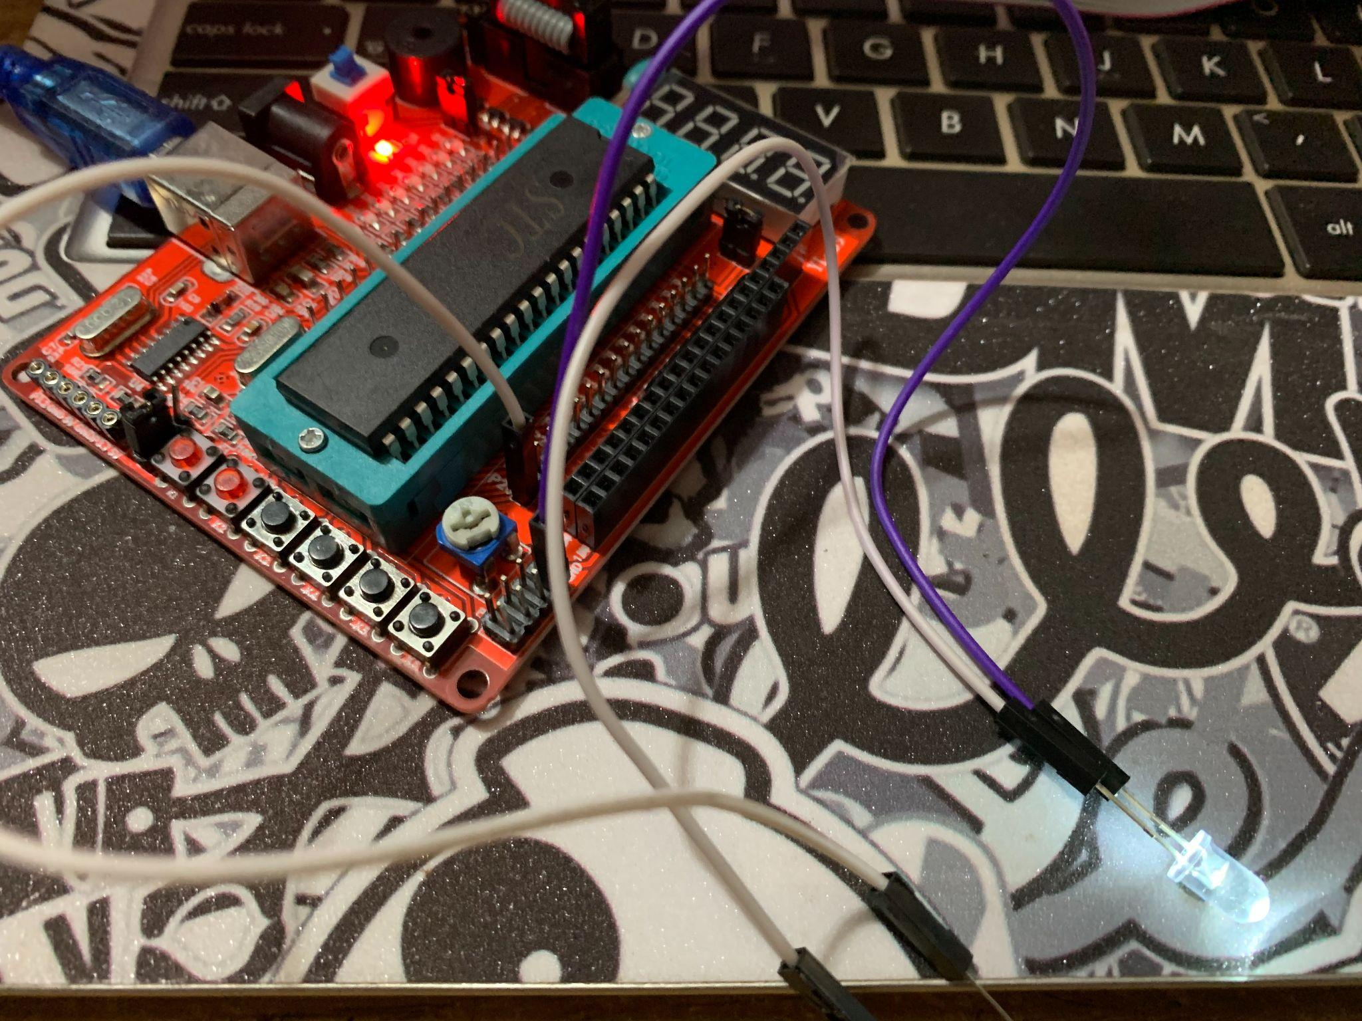

**Discussion:**

In this experiment we’ve designed a circuit that blinks a LED via 8051 Microcontroller. The cheapest we used here was STC89C52RC. For the hardware setup we connect the LED’s positive terminal with a 200 Ohm resistor’s one terminal and the other terminal of the resistor we connect it with Pin 2.0 (Port 2) of the 8051 Kit. The negative terminal of the LED is connected with the GND pin of the kit. For this test we need to write a program using Micro C language. From the program we build a .Hex file that we load into our cheap. To load the program, we used USBASP USBISP AVR Programmer. Via this USBASP USBISP AVR Programmer we load our .hex file into the cheap. So, after downloading the hex file into our cheap LED that we connected with port 2.0 it started blinking. In our Proteus Simulation we connected a crystal and 2 capacitors with our 8051 Microcontroller. And connect the LED with port 2.0 of 80C51. We used the same hex file here. We put the hex file into an 8051 Microcontroller. And after running the Simulation the LED also started blinking.